PRIMARY FIVE LESSON NOTES

FOR TERM TWO
2023.

TERM II TOPICS.
- Components of the environment (soil)
- Matter and energy
- Occupations in our community (crop growing)
- World of living Things (bacteria and fungi)
COMPONENTS OF THE ENVIRONMENT:
WEEK 2
LESSON 1
SOIL
Soil is the top most layer of the earth in which plants grow.
HOW SOIL IS FORMED
  - By weathering.
  - By decomposition
Weathering is the breakdown of rocks into soil.
Agents of weathering.
-wind
-Running water
-Temperature changes
Animals
-Chemical reaction between rocks.
Decomposition is the rotting of dead organic matter.
Agents of decomposition.
-Bacteria
-Fungi
Importance of decomposition
-Formation of soil
-Formation of manure
-Reduces faeces in a pit latrine
-Reduces on the volume of garbage.
Dangers of decomposition.
-Produces bad smell
Makes our food to go bad.
Exercise
- Name any two components of the environment that are;
- Living things
- Nonliving things
- Write two dangers of rotting in the environment.
- Give any two agents of weathering.
Activity.
Observing different soil samples.

LESSON 2
TYPES OF SOIL
There are three types of soil
- Clay soil.
- Loam soil.
- Sand soil.
- CLAY SOIL
Characteristics of clay soil
- It has fine particles.
- It has closely packed particles.
- It does not allow water to pass through it very fast.
- It has a high water retention capacity so it easily becomes water logged.
- Clay soil has the highest rate of capillarity.
Importance of clay soil
  - Clay soil is good for pottery work (making ceramics and modeling).
  - Clay soil is good for making bricks for building.
  - Clay soil is good for making tiles for roofing.
Illustration of arrangement of particles in clay soil.

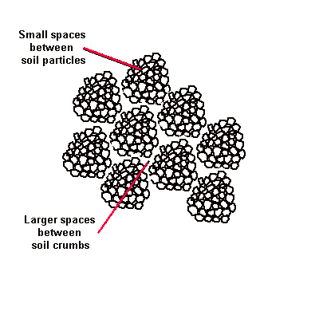
- LOAM SOIL
Loam soil is a mixture of clay, sand soil and organic matter
Organic matter (humus) consists of decayed plants and animal matter
Loam soil usually has adequate water, air and humus to sustain plant growth.
Characteristics of loam soil.
- It’s particles are fairly arranged
- It contains both clay and sand particles.
- It has a lot of humus for plant growth.
- Has fairly larger air spaces as compared to clay soil
Importance of loam soil
  - It is good for crop growing.
Illustration of arrangement of particles in loam soil.
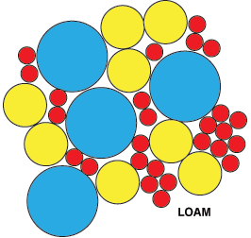

1. Why is loam soil the best for plant growth?
- It contains a lot of humus.

- SAND SOIL
Illustration of arrangement of particles in sand soil.
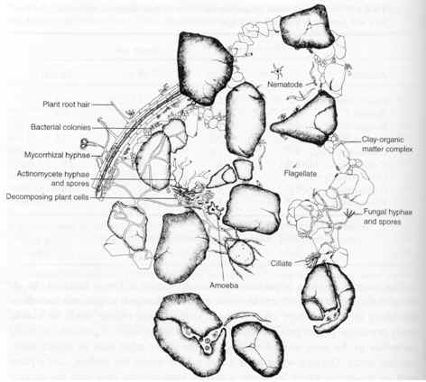
- Has large particles that make it to be well aerated
- Water passes through it easily
- Has poor water retention capacity
- Has high water drainage
- Has a poor rate of capillarity
Capillarity is the up take of water through the soil particles. /
Capillarity is the tendency of water to rise through small narrow spaces.
Drainage is the capacity of the soil to allow water to pass through it.
Importance of sand soil.
- Used for building.
- Used for making glass.
NB. It is not good for crop growing because it has a low water holding capacity.
Exercise:
- Why is loam soil the best for crop growing?
- Mention one characteristic of loam soil
- Identify the type of soil which used for making glass.
- What is capillarity?

Activity:
Carrying out experiment on drainage.

LESSON 3 and 4
COMPONENTS OF THE SOIL
These are things which make up soil, they include:
- Air.
- Water
- Humus
- Rock particles
- Organisms e.g. bacteria and fungi.
Experiment showing the components of soil.

SOIL PROFILE
Is the vertical arrangement of soil layers.
Or
Arrangement of soil layers from top to bottom.
Areas where one can clearly see soil profile.
- Pits – In trenches.

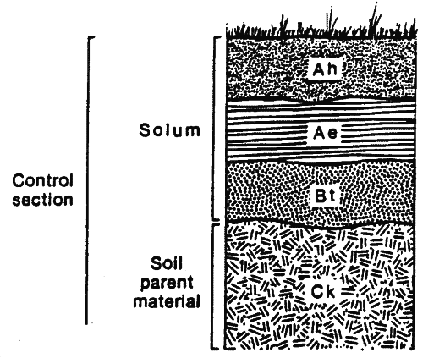
Illustration of the layers of the soil.
Top soil
Sub soil

Bed rock

Parent rock/ gravel

Importance of the top most layer.
- It contains most of the nutrients for plant growth.

- Soil texture. Is the roughness or smoothness of soil particles.
- Soil structure. Is the way soil particles are arranged.
Uses of soil
- People grow crops in soil.
-People use clay soil for pottery
-People construct houses on soil
-It is a habitat of animals
-People carry out mining
Exercise:
- What is soil profile?
- Name the soil layer which good for plant growth.
- Suggest any place where one can clearly soil profile.
- What is soil texture?
- Give two ways soil helps people to survive.

Activity:
  - Experiments on properties of soil.
  - Observing soil profile.

LESSON 5 and 6.
SOIL EROSION
Is the removal of top soil by its agents.
AGENTS OF SOIL EROSION
These are forces that carry away top soil from one place to another. These include:
- Flowing water
- Wind
- Animals
CAUSES OF SOIL EROSION
These include:
- Deforestation
- Overgrazing
- bush burning
- Monoculture (mono-cropping)
- Over cultivation.
- Overstocking.
TYPES OF SOIL EROSION
  - Sheet erosion –uniform removal of top soil in thin layer by overload flow.
  - Gulley erosion –Carrying of top soil through deep water channels.
  - Rill erosion –Carrying away topsoil by runoff water through shallow channels.
  - Splash erosion –Removal of thin soil layer when raindrops hit bare soil.
  - River bank erosion-Carrying of soil into the river as silt.
  - Wind erosion-Carrying away of top soil by wind especially in dusty storms.
Effects of soil erosion.
- Leads to soil exhaustion.
- Leads to siltation of water bodies
CONTROL OF SOIL EROSION.
- Terracing: reduces the speed of running water
- Strip cropping: reduces the speed of running water
- Contour ploughing: is the ploughing across a slope.
It helps to reduces the speed of running water
- Afforestation: is planting of trees where they have ever existed. This also keeps the soil covered from direct rain drops.
- Re-afforestation: is the planting of trees where they have been ever existed. This also keeps the soil covered from direct rain drops.
- Cover cropping: planting cover crops between plants that take long to mature.
Cover crops
These are crops that are planted between plants that take long to mature
Qn: How does cover cropping prevent soil erosion?
Cover crops reduce the speed of running water
Qn: How does inter-cropping reduce soil erosion?
Reduces the speed of running water
- Bush fallowing: resting period of land to regain its fertility
Importance: enables the land to regain its fertility
- Mulching: is the covering of top soil with dry plant material (dry plant materials)
Advantages of mulching.
- Controls soil erosion. How? By reducing the speed of running water.
- Maintains soil fertility. How? By reducing soil erosion and mulches rot to from humus.
- Keeps water in the soil. How? By controlling the rate evaporation of water from the soil.
- Increases on the crop yields.
- Reduces the rapid growth of the weeds.
Disadvantages of mulching
- Mulches keep pests.
- Dry mulches can be fire hazards.
- Some mulches can grow into weeds.
How soil loses its fertility
Through:
- Leaching. It is the sinking of plant nutrients deeper into the soil where plant roots can’t reach.
- Soil erosion.
- Monoculture (mono-culture)
- Bush burning
How can we improve soil fertility?
- Mulching
- Crop rotation
- Bush fallowing
- Addition of fertilizers
- By terracing
- A forestation
Exercise:
1. Give one effect of soil erosion in the environment.
2. How does deforestation lead to soil erosion?
3. Give any three causes of soil erosion
4. Name two types of soil erosion.
Activity:
    - Mulching.

Lesson 7
Soil pollutants.
These are substances that lower the quality of soil.
Examples:
-plastics
-polythene
-chemicals and oils
-metallic materials
-concrete
Effects of soil pollutants
-They prevent water and air from entering the soil.
-Leads to poor soil structure.
Ways of handling soil pollutants.
-Re using
-Returning
-Recycling
-Rejecting
-Reducing
SOIL CONSERVATION
Is the maintaining (preserving) of soil fertility?
Methods of soil conservation
- Afforestation
- Re-afforestation
- Bush fallowing
- Terracing hilly areas
- Rotational grazing
- Contour ploughing
- Strip cropping
- Crop rotation
- Mulching
- Cover cropping
- Mixed farming
- Manuring /application of the fertilizers
- Agro-forestry.
Importance of soil conservation
- Retains soil fertility
- Retains soil moisture
- Prevents spread of diseases and pests.
Soil exhaustion:
It is the ability of the soil to lose fertility.
Causes of soil exhaustion:
- Soil erosion
- Leaching.
- Over cultivation
Mono cropping.
SOIL BARRIERS
These are things (materials) that prevent soil from being carried away by the agents of soil erosion.
Examples of soil barriers
- Grass ( cover crops)
- Trees /roots
- Rocks
- Concrete walls
- Contours
- Gabions. Etc
Exercise:
- What is soil conservation?
- Mention one way of conserving soil.
- Briefly explain the term soil exhaustion.
- How does terracing reduce soil erosion?

WEEK 3
LESSON 1 and 2
FERTILISERS.
These are substances put in the soil to increase it’s fertility.
Types fertilizer
- Artificial fertilizers.
- Natural fertilizers.
ARTIFICIAL FERTILIZERS
Are fertilizers got from inorganic matter.
Types of artificial fertilizers
- Straight fertilizers.
- Compound fertilizers.
Straight fertilizers.
These are fertilizers that supply one nutrient to the soil.
Examples: SSP (single supper phosphate), nitrogen, phosphorus, potassium.
Compound fertilizers.
These are fertilizers that supply more than one nutrient to the soil.
Examples: dramonium phosphate, NPK(Nitrogen, Phosphorus, Potassium)
CAN –Calcium, Amonium, Nitrate.
Advantages of using artificial fertilizers
- They have a high nutrient content needed by the plants.
- They are less bulky to carry and store.
- They provide the needed minerals with out fail.
Disadvantages of using artificial fertilizers
- They are expensive to buy.
-They require skilled labour to apply it.
- They stay in the soil for a shorter period.
- They are poisonous to animals, people and birds.
- They pollute water sources when washed there.
- They destroy soil texture and structure.
- They make the soil acidic.
- They kill organisms in the soil.
Exercise
  - What are fertilizers?
  - Give one effect of the continuous use of artificial fertilizers.
  - How are straight fertilizers different from compound fertilizers?
Activity;
Application of fertilizers.

LESSON 3
Natural fertilizers (manure)
These are fertilizers made from decayed plant and animal materials (humus)
Types of natural fertilizers (manure)
There are four types of manure
1. Compost manure
2. Green manure
3. Farm yard manure
4. Organic mulch.
Compost manure
Is got from both plant and organic waste matter left to decay.
Things used to make compost manure.
- Banana peeling.
- Dry grass
- Maize stalks
- leaves.
COMPOST HEAP/PILE.
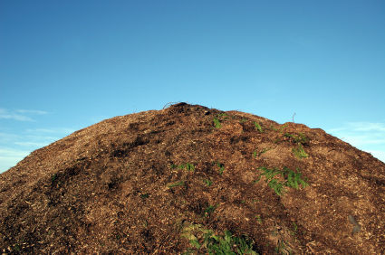

Importance of compost manure
- improves soil fertility)
- Improves soil structure
Nb: When making compost manure, water should be added to the compost heap to make the rotting faster.

Green manure
It is made from green crops especially legumes that are ploughed back into the soil at the flowering stage.
Why legumes? They can rot in a shorter time.
Farm yard manure
Is the manure got from animal wastes like dung and urine mixed with their bedding materials?
Exercise.
- How is Farm Yard manure different from Green manure.
- Name any two materials for making a compost heap.
- Why should water be added into a compost heap?

Activity.
Making a compost heap

Lesson 4.
MATTER AND ENERGY
Energy is the body’s ability to do work
Matter
Matter is anything that has mass and volume

  - Mass: is a quantity of matter in an object.
  - Volume: Is the space occupied by an object.
c. Molecules: It is the smallest particles of matter.
d. Weight: is the gravitational force exerted on an object by the earth.
States of matter
There are three different states of matter

- Solids
- Liquids
- Gases

Examples of solids.
- Wood
- Rubber
- Glass -Plastic
Characteristics of solids.
- Molecules are closely packed.
- Particles are held together very tightly.
- Molecules do not move from position but vibrate.
- Solids have shape, size and volume apart from irregular objects.
Diagram to show the arrangement of molecules.

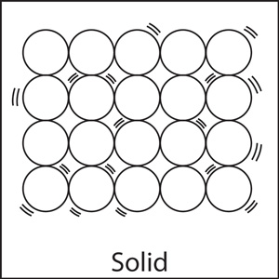

Liquids
Examples of liquids.
- Water -Soda - Oils -Juice
Characteristics of liquids.
- Molecules are spaced.
- Molecules loosely held together.
- Liquids have a proper volume (capacity)
- Liquids have no definite shape (take up the shape of the container in which they are poured)
Diagram to show the arrangement of molecules.
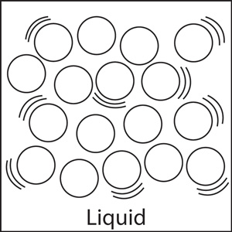
Gases
Examples of gases.
- Nitrogen - Carbon dioxide - Oxygen - Rare gases
Characteristics of gases.
- Molecules are far apart
- Gases have no definite shape
- Gases have a particular volume.
- Molecules move freely.
Diagram to show the arrangement of molecules.

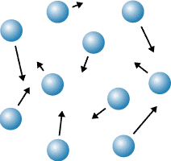
Exercise:
- What is energy?
- Write any two differences between mass and weight.
- In which state of matter are the following
  - water
  - metal
  - oxygen
Activity:
- Drawing diagrams showing arrangement of molecules of matter.

Lesson 5.
Mixtures
A mixture is when two or more different substance are mixed together e.g. when we mix sand and cement we get concrete blocks
Dissolving substance/ solutes.
These are substances that dissolve when put in water/ any liquid after stirring.
So, solutes are soluble in water or the liquid
Examples of solutes.
- Sugar
- Salt
- milk powder
Insoluble substances.
Substances which don’t completely dissolve in any liquid or water.
e.g. sand, maize flour, stones etc
A suspension: is a substance where the solute does not completely dissolve in the solvent.
Solvent.
Is a substance in which a solute dissolves.
Examples.
- water
- petrol
- methylated spirit
Nb: Water is universal solvent because it dissolves almost all solutes.
solution.
Is a uniform mixture of a solute and solvent.
saturated solution is a solution which dissolves more solutes after heating it.
Super saturated solution is a solution which cannot dissolve any more solute even offer heating it.

Exercise:
- Briefly explain the following terms
Solution
Solvents
Solutes
Activity:
- Making solutions
- Making mixtures.

Lesson 6
SEPARATION OF MIXTURES.
  - Filtration.
It is a process of separating solid particles from a liquid using a filter.
The solid particles that remain in the filter are called residues.
The liquid that passes through is called a filtrate.
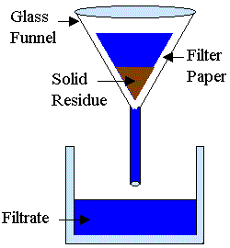
How filtration method can be applied in our homes.
  - When separating passion, orange, etc fruit juice from the seeds.
  - When separating clear water from muddy water.

2. Decantation.
It is when solids particles are allowed to settle at the bottom of a liquid then a liquid is carefully poured off to separate it from the solid particles.

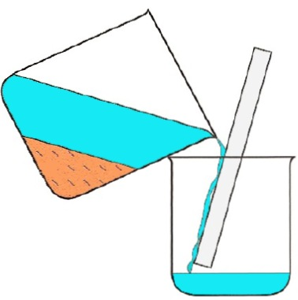
The solid particles that remain in the one container is called a residue.
The liquid that is collected in another container is called a decantee.

How decantation method can be applied in our homes.
1. When separating passion, orange, etc fruit juice from the seeds.
2.When separating clear water from muddy water.
Qn: Why is it important for one to first shake a syrup before taking it?
For the medicine to mix with the liquid that has settled at the top.

Exercise:
- What name is given to the substance formed after filtration?
- How is filtration useful in our daily lives?
Activity:
- Filtering mixtures.
- Decanting.

LESSON 7
- Distillation.
It is the making of dirty water pure by evaporation and condensation.
Nb: Distilled water is not good for drinking because it lacks mineral salts.
The substance that remains in the container is called a residue.
The substance that is collected in the second container is called a distillate.
Distilled water is used to mix drugs in hospitals.
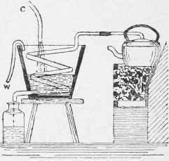
Experiment on how to separate mixtures.
SEPARATION OF MIXTURES OF SOLIDS.
- Floatation.
It is a method of separation of mixtures where one sinks and the other floats.
- Using magnets to separate metallic objects from non metallic objects.
- Hand picking / sorting.

Exercise:
- Briefly explain the term distillation.
- Why is distilled water not good for drinking?
Activity:
- Separating mixtures.
- Distillation.

WEEK 4
LESSON 1
ENERGY
Energy is ability to do work
Forms of energy.
- Heat energy
- Sound energy
- Light energy
- Sound energy
- Electric energy
- Magnetic energy
- Chemical energy
- Solar energy.
Types of energy
- Kinetic energy
- Potential energy

Potential energy
Is the energy that is stored by an object at rest.

Examples of potential energy
- A baby being asleep in a cot
- A car standing still at traffic lights
- A pupil sitting and listening to the teacher
- A stone / book ruler resting on a table /ground /cupboard etc

Kinetic energy
This is the energy possessed by a moving object or an object in motion. It is also referred to as the energy in motion
Examples of kinetic energy
- A girl running along the road
- An arrow flying through the air
- A stone thrown up in air
- A brick dropping from a wall
- A leaf falling to the ground from a tree
Think of a stone or a pendulum swinging in air
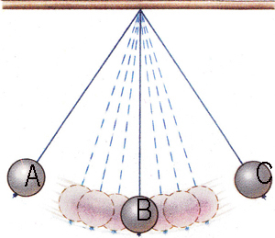
At A, the stone possess potential energy
At B, the stone possess kinetic energy
Exercise:
- Mention the two types of energy.
- Define the following types of energy
  - potential energy.
  - kinetic energy.
- List down any three forms of energy.

Activity:
    - Throwing objects up.
    - Swinging objects when tied at fixed point.

LESSON 2
HEAT ENERGY
Heat energy is a form of energy that increases temperature of an object
Standard units for measuring heat.
joules
Instruments used to measure heat.
Calorimeter
sources of heat
These are objects that produce heat.
Types of sources of heat.
  - Natural sources of heat
  - Artificial sources of heat
Natural sources
Natural sources of heat provided by nature.
Examples.

- Sun (main natural source of heat)
- Food
- Stars
- Erupting volcanoes
Artificial sources.
These are sources of heat made by people.
Examples of artificial sources of heat.
- Lamps
- Bulbs
- Candles
Uses of heat to man
- used for ironing clothes
- Heat is used to run some machines e.g. steam engines. Diesel engines, rockets etc.
- used to dry harvested crops before storage.
- Heat evaporates the water in water bodies and plants during rain formation
- Heat enables us to cook our food
- Heat can act as a disinfectant.
Effects of heat in the environment.
-Heat causes evaporation which help in rain formation.
-Heat provides optimum warmth for plant and animal growth.
-Heat makes water bodies dry up.
-Heat dries crops.
-Heat causes people to sweat.
Exercise
- State two effects of heat in the environment.
- Name the main source of heat in the environment.
- How is heat different from temperature?
Activity
Heating metals.

LESSON 3
EFFECTS OF HEAT GAIN AND LOSS ON MATTER.
SOLIDS.
- Metals expand.
Metallic ball ring experiment
a). Before heating the metallic ball goes through the ring.
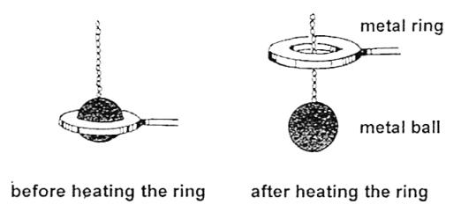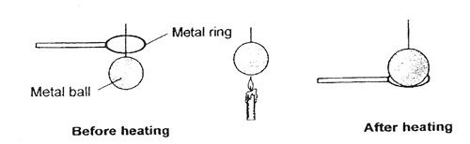

b). after heating the metallic ball does not pass through the ring
Reasons why metallic ball did not go through the ring after heating
The metallic ball had expanded
Conclusion
Metals expand when heated
What do you think can happen to the metallic ball if dipped into cold water?
The hot metallic ball will contract and pass through the ring again.
Bimetallic strip.
Before heating and after heating
NB: replace brass with copper.
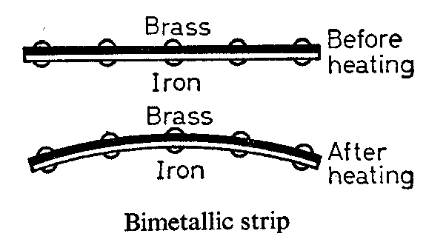
Observation
The copper strip heats up and expands faster than the iron strip hence bending to wards the iron.
Explanation:
Different metals expand differently when heated by the same amount of heat.
Exercise:
- Which of the two metals is the best conductor of heat?
- Give one effect of heat on metals.
Activity:
- Heating copper strip
- Heating metallic balls.

Lesson 5
IMPORTANCE OF A Bimetallic.
- Bimetallic strips are used in automatic switches of electric kettles, flat irons, fridges, freezers etc.
illustration of a railway line showing the gaps left during construction.
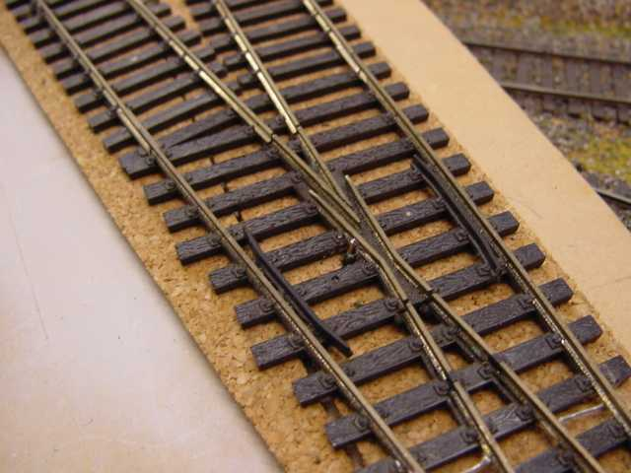
- Why are gaps left between railways during construction?
Ans: To leave room for expansion on a hot day.
- What happens if gaps were not left between rails during construction?
Ans: The rails would expand on hot days bend and cause railway accidents.
Diagrams to show the effect of heat on electric / telephone wires
On a hot day.
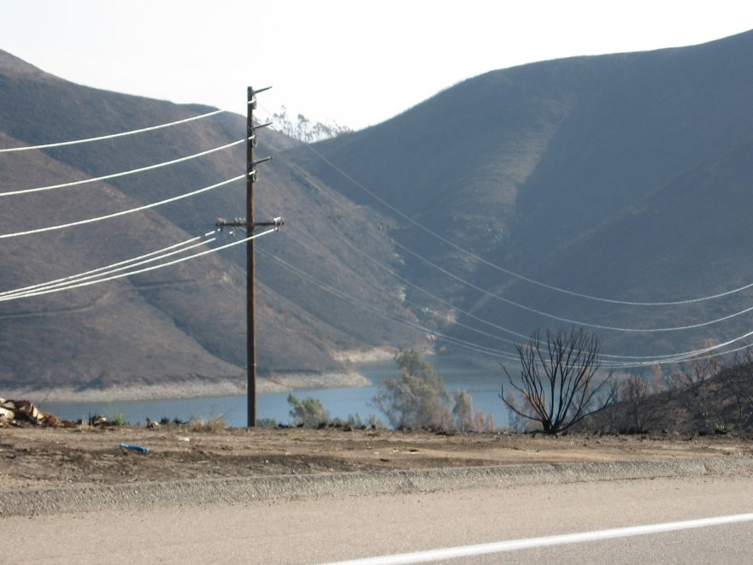
Electric / telephone wires expand become loose and starts sagging / slacking.
On a cold day wire contract and become shorter appearing relatively tight.
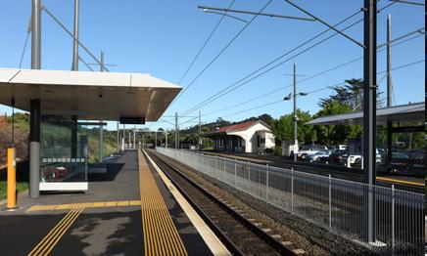
Qn; 1. Why are electric / telephone wires fixed loose on poles?
To allow room for expansion on hot days.
- What would happen to the wires when tied tightly fixed on the poles?
The wires would break due to contraction on cold days
Exercise:
- Why gaps left between the railway lines during construction?
- Why telephone wires are loosely fixed on the poles?
- what happens to electric wires on the following
  - Cold days.
  - Hot days.
Activity:
- Heating metals.
- Nature walk to observe electric and telephone wires.

LESSON 6
EFFECTS OF HEAT ON ICE.
What happens to ice when heated?
- Ice melts
- The volume decreases, the density increases and the mass remains the same.
EFFECTS OF HEAT ON GASES
What happens to gases when:-
a). Heated - Gases expand
b). Cooled - Gases contract
EXPERIMENT TO SHOW THAT GASES EXPAND WHEN HEATED.
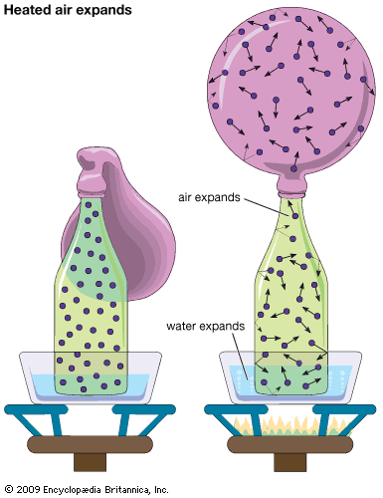
QN:1. Why does the balloon in diagram A expand?
Due to expansion of air inside the plastic bottle.
- What happens to the balloon when the bottle is removed from the hot water?
The balloon collapses due to contraction of the air inside the plastic bottle.

Effects of heat on liquids
- Liquids expand when heated.
- Liquids evaporate when heated.
- Liquids contract when cooled
Effects of freezing on liquids
- Liquids increase in volume
- Liquids reduce in density
- Mass of liquids remains the same.

Diagram to show that liquids expand when heated.
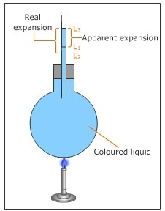
Qn: 1. why is space left while bottling drinks like soda?
To leave room for increase in volume when frozen.
- Why is carbon dioxide packed in bottled drinks like soda?
To preserve the soda.
A BOTTLE WITH THE SPACE LEFT

Space left to give room for
Increase in volume on freezing.
Effects of heat on sublimates
NB: Sublimates are substances which can directly change from solid to gas.
Examples of sublimates
- Iodine granules (crystals)
- Ammonium chloride(salts)
- Solid carbon dioxide.
- Sulphur
Exercise:
- What happens to air when heated?
- Why is space left in a soda bottle?
- What happens to liquids after freezing.
Activity:
Boiling water.

Lesson 7
Change of state of matter.
Heat causes the following changes in states of matter.
- Melting.
- Expansion.
- Evaporation.
- Sublimation.

Diagram to show physical changes of state of matter.
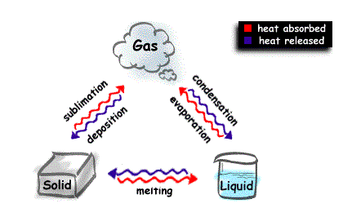
freezing

Melting physical change from solid to liquid
Evaporation physical change from liquid to gas.
Freezing physical change from liquid to solid.
Condensation – Physical change from gas to liquid
Sublimation- is physical change from solid to gas.
Deposition -is physical change from gas to solid.
Exercise:
- What is heat energy?
- Name two the types of sources of heat in the environment.
- Give two examples of each of the following sources of heat
  - Natural source of heat.
  - Artificial source of heat.
- Identify any two effects of heat on a state of matter.
Activity:
- Burning papers.
- Melting wax candles.

WEEK 5 MIDTERM EXAMS

WEEK 6
LESSON 1
HEAT TRANSFER
How heat travels through the states of matter
1. Solids by Conduction
2. Liquids by Convection
3. Gases by Convection
Vacuum by Radiation
Vacuum
A vacuum is a space without molecules.
Importance of molecules in heat transfer
- Molecule act as a medium of heat transfer.
Qn: In which state of matter does heat travel?
A) Fastest – gases
Why? The molecules in gaseous state move freely than in any other state of matter.
Slowest – Solids
Why? The molecules do not move freely.
An illustration of heat transfer in solids
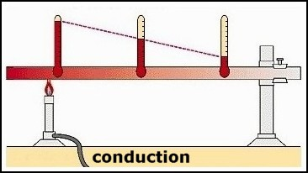
Qn: 1. how does heat move from point B to point A?
By conduction
- Which of the above wax will melt first?
Wax 1.
Reason: Wax 1 is nearest to the flame
- Which of the above wax will melt last?
Wax 4
Reason: wax 4 is furthest from the flame.
Importance of heat transfer by conduction
- Ironing our clothes using hot bodies like flat irons, iron boxes.
- Cooking food.
- Boiling water in a kettle.
- Welding or smelting metallic objects.
- Roasting meat using an iron rod.

Diagram to show convection of heat
- in gases.
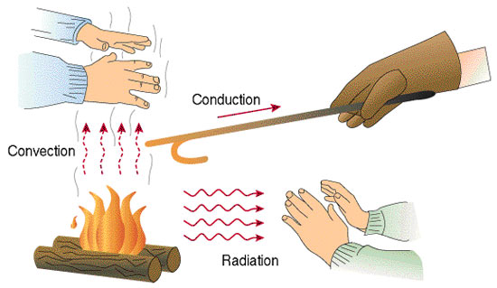

- liquids
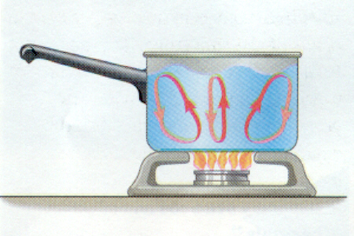

Importance of convection in our daily life
- helps smoke to move out of the kitchen through the chimney.
- Convection current helps in free circulation of fresh air in our houses.
- Convection currents help in formation of breezes.
- Taking of bad smell through the vent pipes of a VIP latrine.
Importance of each of the following on a house.
1. Ventilators: let out warm air
2. Windows: let in fresh air
3. Doors: let in fresh air

Exercise
1. How does heat travel through the following
- Solids?
- Liquids?
- Gases?
- Vacuum?
- In which state of matter does heat travel
- fastest
- slowest
Activity:
  - Heating wax on a metallic rod
  - Boiling water.

LESSON 2
SEA AND LAND BREEZE.
Sea breeze.
It is when cool gentle current from the sea moves to the land to replace the warm risen air. It occurs during day.
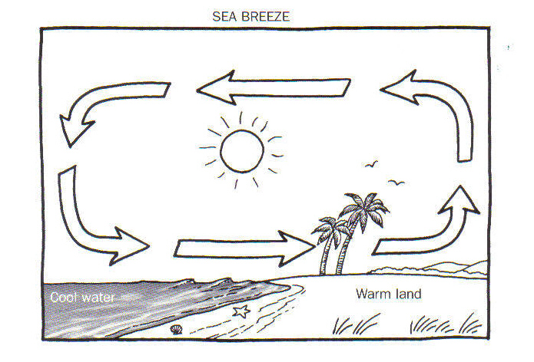
land breezes.

It is when cool gentle current from the land moves to the sea to replace the warm risen air. It occurs at night.

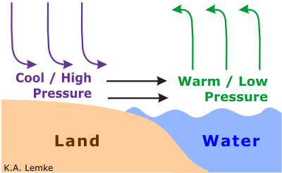
Nb: Sea breeze brings cool fresh air on land.
RADIATION.
It is the process by which heat passes through a vacuum.
QN: How does a person standing in Namboole on sunny day receive heat from the sun?
By radiation.

Importance of heat transfer by radiation in the environment
- Radiation is used while roasting meat, fish or chicken in an oven.
- Warming our bodies using warmers or heaters.
- Dries harvested crops / wet clothes on wires.
Reflectors and absorbers or heat.
Reflectors: are shiny surface that reflect heat and light
Absorbers: are dull / black surface that absorb heat and light.

Examples of reflectors
- Mirrors
- Glasses
Absorbers
- Black clothes
- Black cars
Why are most houses, vehicles and fridges in most tropical countries like Uganda painted white? To reflect heat
If John washed a black and a white shirt and spread under sunshine;
  - Which shirt would dry first? The black shirt.
Reason: Black absorbs a lot of heat.
Last? The white shirt
Reason: The white shirt would reflect heat.
Conductors and insulators of heat
Good conductors: - are materials which allow heat to pass through them easily.
Examples of good conductors of heat

- Iron
- Mercury
- Aluminum
- Brass
- Zinc
- Copper
- Silver
- Lead

Insulators of heat
Insulators are the materials which don’t allow heat to pass through them easily.
OR
Insulators are bad (poor) conductors of heat

Examples of bad conductors of heat

- Distilled Water
- Rubber
- Plastic
- Paper
- Cotton wool
- Cloth
- Sponges.

ACTIVITY:
1. How does heat from the sun reach people on earth?
2. State two importance of heat transfer by radiation in the environment.
3. What are insulators?
4. Give four examples of insulators.

Activity:
      - Heating metals.
      - Hanging handkerchiefs.
LESSON 3 AND 4
Experiment to show that water is a poor conductor of heat
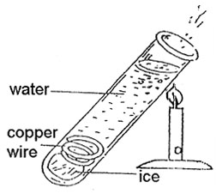
Observation
- Ice did not melt
- The water will boil at the area being heated while the ice cubes at the bottom will not melt.
Use of conductors
- Used to make saucepans
- Used to make kettles
- Used to make bottoms of iron boxes
Insulators
- Paper is used to make cards
- Cloth keeps us warm
- Cork prevents heat loss in a vacuum flask.
- Why are handles of iron boxes, frying pans, flat irons made of wood, rubber / plastics?
To prevent the user from getting burnt.

A VACUUM FLASK (THERMOMETER FLASK)
A vacuum flask keeps hot things hot and cold things cold.

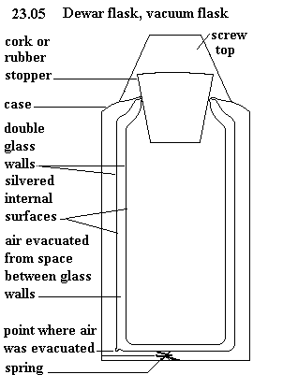
Uses of each part of a vacuum flask
Cork: Prevents heat loss or gain by conduction.
Silvered surfaces: prevents heat loss or gain by radiation (a good reflector of heat).
Vacuum: Prevents heat loss or gain by both conduction and convection.
Felt (cork base): Absorbs shocks to prevent the glass from breaking.
Felt are also poor conductors of heat.
Vacuum seal: Prevents matter from entering the vacuum.
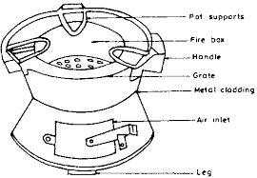
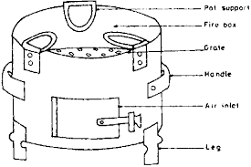
Charcoal stoves.
pot support
Fire box
crate
handle
Air inlet
stand

Exercise
  - Of what importance is the thermos flask at home?
  - Why is a vacuum seal important in thermos flask?
  - What is the use of the cork on the vacuum flask?
  - Why are the walls of a vacuum flask double silvered?

Activity
- Draw a vacuum flask.
- Carry out an experiment to water is a poor conductor of heat.

LESSON 5
TEMPERATURE
Is the degree of hotness or coldness of an object.
Standard units for measuring temperature.
Temperature Degrees
Instrument used to measure temperature.
Temperature Thermometer
Thermometer
Thermometer is an instrument used to measure temperature.
The following thermometer measure the following:-
- Lowest temperature of the day Minimum thermometer
- Highest temperature of the day Maximum thermometer
- Room temperature or temperature of the air Wall thermometer
- Highest and lowest temperature of the day Six’s thermometer
- Human body temperature Clinical thermometer
Places where we find clinical thermometer in daily life
- In clinics
- In hospitals
- In dispensaries
Places or common sites on our bodies where a clinical thermometer can be placed while measuring the human body temperature
- Under the arm pits
- In the anus
- In the mouths / under the tongue

Diagram of clinical thermometer

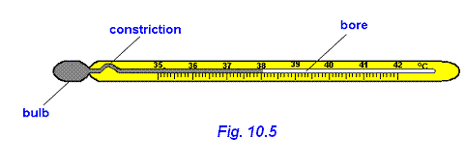
Importance of each part
Stem: Protects the inside parts of a thermometer
Kink: Prevents the back flow of mercury to the bulb before the actual temperature is taken.
Bore: The bore has a regular scale.
Bulb: The bulb store mercury.
Liquids commonly used in thermometers.
- Alcohol
- Mercury
Exercise:
- What is temperature?
- State the difference between heat and temperature.
- Name the any one type of thermometer.
- Which liquids are used in the thermometers
Activity:
- Drawing and observing the parts of a clinical thermometer.

LESSON 6
SIX’S THERMOMETER ( MINIMUM AND MAXMUM THERMOMETER)
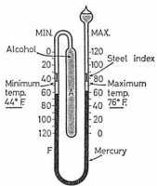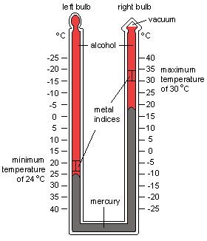
Reasons why mercury is used in a thermometer
- Mercury is a good conductor of heat
- Mercury does not stick on the walls of the bulb / bore.
- Mercury can easily be seen in the glass.
- Mercury has even and regular expansion.
Reasons why water is not used in a clinical thermometer
- Water is not easily seen
- Water is a bad conductor of heat
- Water needs a lot of heat to expand.
- Water’s does not expand uniformly.
Why do doctors shake a clinical thermometer before using it on other patients?
- To draw the mercury back to the bulb
Reason why a clinical thermometer is sterilized using surgical spirit
- Boiling it will make the stem expand and burst.
The normal human body temperature
- Celsius 37⁰c.
- 98.6/ 98.4degrees Fahrenheit.
Exercise:
- State the normal body temperature of a human being in degrees Celsius.
- Why is mercury commonly used in thermometers?
Activity:
- Drawing thermometers.
- Shaking a clinical thermometer.

LESSON 7
Changing from Celsius to Fahrenheit

  - 20⁰c
F = (c x 9) + 32⁰
5
F = (20 x 9) + 32
5
F = (4 x 9) +32
F = 36 + 32
⁰F = 68⁰
  - 25⁰c
F = (c x 9) + 32⁰
5
F = (25 x 9) + 32
5
F = (5 x 9) +32
F = 45 + 32
⁰F = 77⁰
  - 5⁰c
F = (c x 9) + 32⁰
5
F = (5 x 9) + 32
5
F = (1 x 9) +32
F = 9 + 32
⁰F = 41⁰

F = (c x 9) + 32⁰
5
F= (0 x 9) + 32
5
F = (0 x 9) +32
F = 0 + 32
⁰F = 32⁰

  - 80⁰c
F = (c x 9) + 32⁰
5
F = (80 x 9) + 32
5
F = (16 x 9) +32
F = 144 + 32
⁰F = 176^{0c}

  - 100⁰c
F = (c x 9) + 32⁰
5
F = (100 x 9) + 32
5
F = (20 x 9) +32
F = 180 + 32
⁰F = 212⁰

Exercise:
Change the following from degrees Celsius to degrees Fahrenheit
- 5^{oc}
- 10^{0c}
- 100^{0c}
- 0^{0c}
- 8^{0c}

Activity:

- Drawing thermometers.

WEEK 7
Lesson 1
Changing temperature from Fahrenheit to Celsius

Example 41⁰F to C⁰

C = (F – 32) x ⁵/₉
C = (41 – 32) x ⁵/₉
C = (41⁰ – 32) x ⁵/₉
C = 9 x ⁵/₉
C = 1 x 5
C = 5⁰

Change 68⁰F to C⁰
C= (F – 32) x ⁵/₉
C = (68⁰ – 32) x ⁵/₉
C = 36 x ⁵/₉
C= 4 x 5
C = 20⁰

Change 32⁰F to C⁰
C = (F – 32) x ⁵/₉
C = (32⁰ – 32) x ⁵/₉
C = 0 x ⁵/₉
C = 0 x 5
C = 0⁰
Change 59⁰F to C⁰
C = (F – 32) x ⁵/₉
C= (59⁰ – 32) x ⁵/₉
C = 27 x ⁵/₉
C = 3 x 5
C = 15⁰

Change 95⁰F to C⁰
C= (F – 32) x ⁵/₉
C = (95⁰ – 32) x ⁵/₉
C = 63 x ⁵/₉
C = 7 x 5
C = 35⁰

Change 77⁰F to C⁰
C = (F – 32) x ⁵/₉
C= (77⁰ – 32) x ⁵/₉
C= 45 x ⁵/₉
C = 5 x 5
C = 25⁰

Exercise
Change from Fahrenheit to Celsius
- 68^{0c}
- 32^{0c}
- 41^{0c}
- 77^{0c}

LESSON 3
OCCUPATIONS IN OUR COMMUNITY: CROP GROWING
CROP GROWING
ROOT CROPS
Root crops are crops that store their food in the swollen underground roots.
Examples of root crops
- Cassava
- Sweet potatoes
- Carrots
- Turnips
STEM TUBERS
Are crops which store their food in swollen underground stems.
Examples of stem tubers
- Coco yams
- Irish potatoes

Which food values do we get from eating mostly root crops.
We get carbohydrates.
How are the following crops propagated?
Crop | Propagation
Cassava | By planting stem cuttings
Sweet potatoes | By planting vines / stem cuttings
Carrots | By planting carrot seeds
Coco Yams | By planting the corms
Turnips | By planning seeds
Irish potatoes | By planting stem tubers

CARING FOR ROOT CROPS
- By weeding the root crops
- Pruning the crops
- Thinning
- Watering
- Watering
- Application of fertilizers
- Manuring
Exercise:
- What are root crops?
- Give three examples of root crops.
- State two reasons why people grow root crops.
- Why is a sugar cane not grouped under stem tubers?
- how are the following crops propagated
  - cassava
  - sweet potatoes c ) bananas
Activity:
    - Pruning crops
    - Thinning
LESSON 7&8
ROOT CROP PESTS AND DISEASES
Pests:
Pests are living organisms that destroy crops e.g. birds, worms, insects, rodents etc
Diseases:
Diseases are illness /sickness in living organisms i.e. plants and animals.

A TABLE SHOWING THE PESTS AND DISEASE THAT AFFECT VARIOUS ROOT CROPS
Pests | Crop | Part attacked | Prevention and control
Whitefly, monkeys, cassava scale, green cassava mites, caterpillars, wild pigs, rodents e.g. moles | cassava | Leaves  Root tubers | Spraying using pesticides  Setting traps
Eel worms, caterpillars, sweet potatoes, weevils, wild pigs, monkeys, rodents | Sweet potatoes | Leaves  Root tubers | Spraying using pesticides  Setting traps
Aphids, moles, eel worms, cut worms, root knot, nematodes | Carrots | Leaves  Root tubers | Spraying using pesticides  Setting traps
Termites, Locusts, Mole, Yam beetles | Coco yams | Leaves  Root tubers | Spraying using pesticides  Setting traps
Signs of pests in root crops
-wilting
-yellowing of the leaves
-rotting of the tubers
-leaf curling
DISEASES OF ROOT CROPS
Disease | Crop | Control
Anthracnose | All root crops | -Spraying pesticides  -Early planting  -Plantingresistant varieties
Cassava mosaic, leaf spot, bacterial blight | cassava
Bacterial wilt, potato blight | Sweet potatoes
Leaf spot, bacterial wilt | carrot

HOW TO CONTROL CROP PESTS
- By spraying the crops with pesticides.
Dangers of pests to crop farmers
- Pests damage farmer’s crops
- Reduce on the crop yields
- Cause decaying root crops
- Wastes money to control
Uses of pests to farmers
- Some pests are a source of food to man e.g. grasshoppers and locusts.

- Some are eaten by farmer’s poultry e.g. caterpillars
Exercise:
- What is thinning?
- Of what importance is thinning to a crop farmer?
- Identify any one garden tool for pruning crops.
- What are pests?
Activity:
- Pruning crops.
- Thinning crops.
- Spraying pesticides.

WEEK 7
LESSON 1
FOUR MAJOR CONTROL METHODS OF PESTS
- Mechanical control method
E.g.
  - physical guarding
  - Fencing the garden
  - Setting traps /snares
  - using scare crows
  - Regular weeding
The above methods can control pests like wild pigs, moles, rodents etc
- Biological pest control
This is where a predator is used to control the pests e.g. you can tame a cat to kill rats.

- Cultural methods
- By practicing crop rotation
- Early planting
- Planting resistant species /varieties
- Through proper control of weeds
- By planting disease free cuttings /vines
- Chemical control method;
Is a method where a farmer sprays pesticides /insecticides to kill the pests
Note; Instruments used to spray the crops are;
-Knapsack sprayer
-Hand sprayer.
HARVESTING OF ROOT CROPS
Harvesting
Harvesting is the removal of mature and ready crops from the garden.

Methods of storing root crops
- Temporary storage e.g. burying the tubes under wet soil
- Long time storage (after drying the slices) e.g. storing in granaries /sacks /slices (modern stores) silos
- Exercise
- What is harvesting?
- Why is dry season important to crop farmers?
- Suggest one biological method of controlling crop pests.
- Mention one method of harvesting crops.
- Name the modern method of storing harvested crops.
Activity
- Building granaries.
- Uprooting cassava.

LESSON 2&3
KEEPING AND USING FARM RECORD
Farm records
These are details or information concerning all activities that take place on a farm.
Example of farm records used on root crops
- Farm inventory e.g. farm equipment size of lands.
- Income and expenditure
- Labour records
- Production records

Importance of keeping farm records
- To know the progress of the farm
- Proper records can be used to get loans in the bank
- To plan for the farm for future use
- To know whether the farmer is making profits or losses.
SPECIMEN OF FARM RECORDS SHEET
Date of planting | Crop planted | Date of weed control | Date of manuring | Date of harvest | Date of sale
2/2/2018 | Cassava | 3/3/2018 | 3/4/2018 | 7/7/2018 | 8/7/2018

SCIENCE CLUBS /SOCIETIES IN THE SCHOOL
The science club
Involve learners in science related activities
Examples of Science oriented clubs.
- Wildlife clubs
- Red cross clubs
- Young farmers clubs
Importance of science activities to learners
- Develop a positive attitude in learners towards science.
- Expose learners to the kind of work that can lead to their career
- Shape learners for their future career in the science field i.e. doctors, engineers, surgeons, dentists, electricians, and agriculturalist.

Wildlife club
Enables learners to learn more about uncultivated crops and wild animals that exist in the natural environment.
Roles of the wild life club
- Protecting the environment
- Teaching or sensitizing others to protect or conserve the environment.
Activities done by the wildlife clubs in school
- Planting trees in the school
- Tree labeling
- Sensitizing members on conservation of the environment
- Setting up a botanical garden
Aims of the science oriented clubs in school
- To promote /boost children’s interests in the science subject
- To equip learners with knowledge and skills for their future career.
- To promote learning of science in the school.
The young farmers clubs
The young farmers clubs include young boys and girls in and out of school who are interested in farming.
Roles of the young farmers clubs
- To keep animals and grow crops.
- To teach other children better farming methods.
Topical questions
  - How can root crops be cared by crop farmers
  - Give any two examples of stem tubers
  - State the importance of farm records on a crop farm
  - Identify the main role of the wildlife club in a school like greenhill
  - Which is the best season for crop growing
  - How are the following crops propagated
Sweet potatoes
Cassava
Carrots
  - Which food value is mostly obtained from root crops
  - Give the difference between a pest and a parasite.
Activity:

- Planting crops.

BACTERIA AND FUNGI
Bacteria are single celled microscopic organisms.
Places where bacteria are mostly found
- Animal bodies
- Contaminated water
- Soil
- Nodules of legumes
- Latrines
- Rubbish pits
- Air
- Contaminated food
Characteristics of bacteria
- Bacteria are single celled(unicellular)
- They are microscopic
- They have cell wall for protection
- They have flagella(tail for movement)

How do bacteria reproduce
- By cell division (binary fission)

Conditions that favour multiplication of bacteria.
-food
-moisture
- warmth
Types of bacteria
- Bacilli - Rod shaped bacteria.
- Cocci - Spherical shaped bacteria
- Spirilla - Spiral shaped bacteria
- Vibrios – Comma shaped

1 bacilli . Rod shaped bacteria
e.g bacillus anthraces for anthrax, salmonella typhi for typhoid
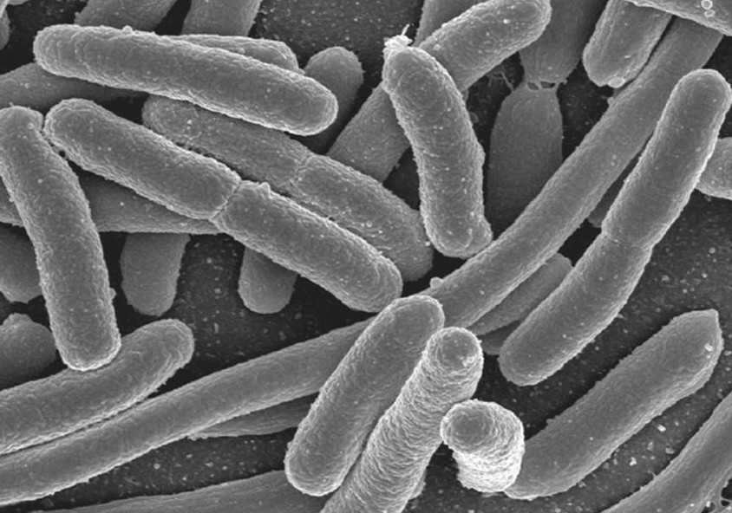

2. cocci e.g. staphylococci for boils, streptococcus for sore throat, diplococci
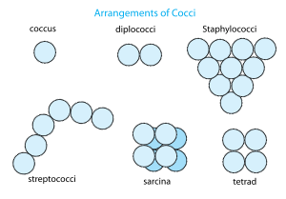
3. spirochaete for syphilis
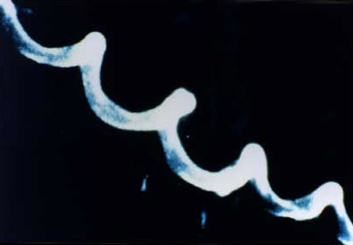
- vibrios Coma shaped bacteria
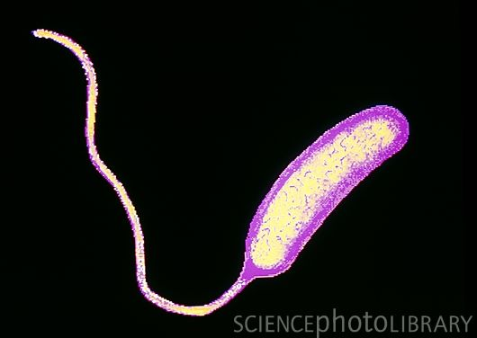
Exercise:
- What are bacteria?
- How do bacteria reproduce?
- Identify one place where bacteria can be found.
Activity:
- Using a microscope for viewing bacteria.
- Nature walks to areas where bacteria can be found.

LESSON 6
Nature of bacteria
-Harmful bacteria
-Useful bacteria e.g
Nitrogen fixing bacteria, Nitrifying bacteria, Denitrifying bacteria
Importance of bacteria
- Nitrogen fixing bacteria fix nitrogen back into the soil to improve soil fertility
- Bacteria help in decomposition / rotting of dead plants and animals
- Bacteria help too reduce on the amount of faeces in pit latrines as well as sewage tanks
- Bacteria help in fermentation of beer, ghee, yoghurt and cheese.
- Bacteria help in making humus (manure) in compost pits)
- Bacteria help to reduce on the amount of garbage as they rot.

Dangers of bacteria
1. Harmful bacteria cause diseases to both animals and plants.
2.Bacteria cause food poisoning
3.contaminates food and makes it poisonous to human health
4.Some cause diseases.
Diseases caused by bacteria
Animals | Prevention /control | Treatment
People  Tuberculosis, Cholera, Tetanus,Typhoid | -Immunization  -Washing hands after using the latrine  - Boiling water for drinking. | Treat with antibiotics.
Farm Animals  Anthrax, Fowl typhoid | -Vaccination | Treat with antibiotics
Plants  Bacterial wilt, Bacterial leaf blight | Planting disease free materials  -Early planting

Exercise:
- Give any one example of bacterial disease.
- State any two ways of controlling bacterial infections.
Activity:
- Boiling milk.
- Uprooting some crops with root nodules.

LESSON 7 & 8
FUNGI
Fungi are simple organisms that obtain their food from decaying plants and animal matter.
Fungi are saprophytes because they feed saprophytic ally (obtain soluble food from dead organic matter)
Examples of fungi
- Mushrooms
- Moulds
- Yeasts
- Puffball
- Toad stools

Characteristics of fungi
- Fungi exist both as single celled (unicellular) or multicellular organisms.
- Fungi lack chlorophyll
- Fungi feed either saprophytically or parasitically
- They have nuclei in their cells

Importance of fungi
- Some fungi like yeast are used in baking bread
- Some fungi like mushrooms are eaten by man
- Some fungi like moulds are used to make penicillin
- Yeast is used for fermentation of alcohol.
- Fungi help in decomposition of rubbish in rubbish pits to make humus
- Yeast is used to flavors cheese
- Yeast is a source of vitamin B that prevents beriberi

Mushrooms
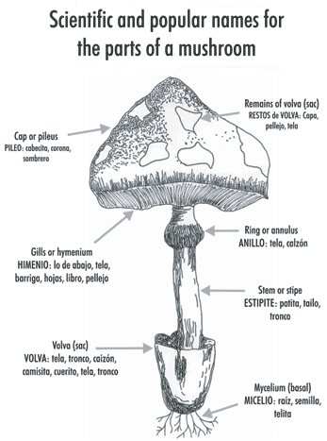
IMPORTANCE OF MUSHROOMS.
- They are eaten as food.
- Some mushrooms are sold to get money.

Exercise:
- What are fungi?
- How do fungi reproduce?
- Give examples of fungi.
Activity:
- Drawing mushrooms.
- Growing mushrooms.

WEEK 8
LESSON 1&2
How do fungi reproduce?
Most fungi reproduce by means of spores unlike Yeast which reproduces by budding
Diagram
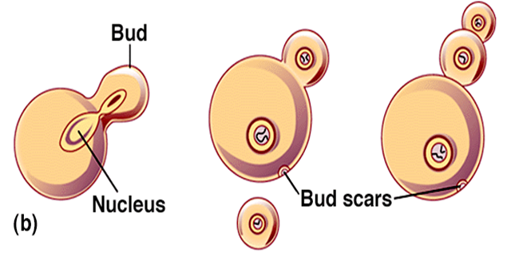
Danger of harmful fungi
- Harmful fungi cause food poisoning
- Harmful fungi cause a number of diseases to both plants and animals
Examples of fungal diseases in animals
- Ring worms (cause round patches on the skin)
- Athletes foot (attacks the skin between the hoes)
- Thrush caused by candida
- Finger nail deformation

Examples of fungal diseases in plants
- Panama e.g. banana
- Cigarand rot
- Blast wilt
- Coffee berry disease (rust) coffee plant
- Root rot in tea plants.
How to control the dangers caused by harmful fungi
- Boiling milk and water before drinking.
- Reheating and warming cold food before eating it.
- Salting the food.
- Pickling – putting vinegar in edible vegetables and other foods.
- Avoid eating uncovered food.
- Spray plants with fungicides.
- Get early treatment for any fungal infection /disease.
- Sterilize all surgical instruments to kill all the germs.
- Irradiation in canned foods.
- Avoid eating or catching poisonous fungi.
- Proper management of house refuse and rubbish
- Proper use of the latrine.
- Avoid sharing towels, socks, under wears etc.
- Use medicated soap to bathe e.g. detol , protex, etc.
- Use disinfectants in cleaning toilets e.g. jeyz.
Similarities between bacteria and fungi
- Both have cell walls

Differences between bacteria and fungi
- Bacteria reproduce by means of cell division (binary fission) while fungi reproduce by means of budding and spores.
- All bacteria are very tiny microscope while some fungi like mushrooms are big
- Bacteria reproduce much faster than fungi

Topical questions
1. How are bacteria different from fungi?
-----------------------------------------------------------------------------------------------
2. Where are bacteria found in our environment?
-----------------------------------------------------------------------------------------------
3. Name any one poisonous fungi
-----------------------------------------------------------------------------------------------
4. Give the three types of bacteria
-----------------------------------------------------------------------------------------------
5. Which bacteria do the following?
a) Add nitrogen back into the soil
-----------------------------------------------------------------------------------------------
b) Make food go bad
-----------------------------------------------------------------------------------------------
c) Cause typhoid
----------------------------------------------------------------------------------------------
d) Cause cholera
-----------------------------------------------------------------------------------------------
6 Identify any two immunisable disease caused by bacteria
-----------------------------------------------------------------------------------------------
7 How do the following reproduce?
a) Yeast -----------------------------------------------------------------------------------
b) Bacteria----------------------------------------------------------------------------------
8 Give the importance of fungi to people
-----------------------------------------------------------------------------------------------
9 How are bacteria useful to people?
-----------------------------------------------------------------------------------------------
10 In the space below, draw a mushroom and label all the parts
Activity:
- Using a magnifying lenses to view spores.
- Drawing diagrams to show budding in fungi.

